How to install GenyMotion?

1.Go to GenyMotion official site  
2. Register with User type “Gaming”  
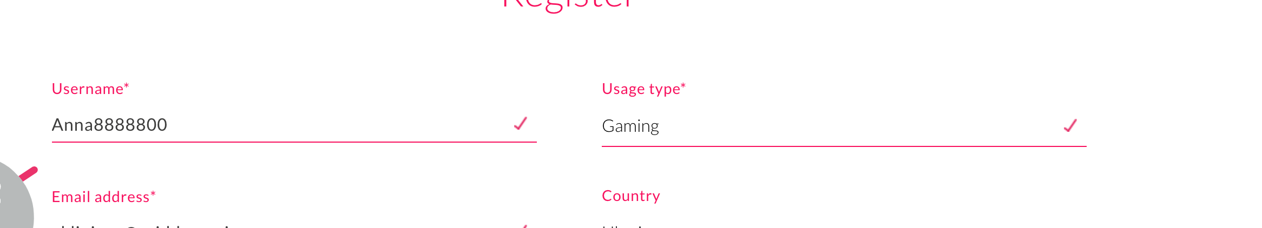

3. Go to your e-mail and confirm your registration by typing the activation link.  
The next picture should be displayed

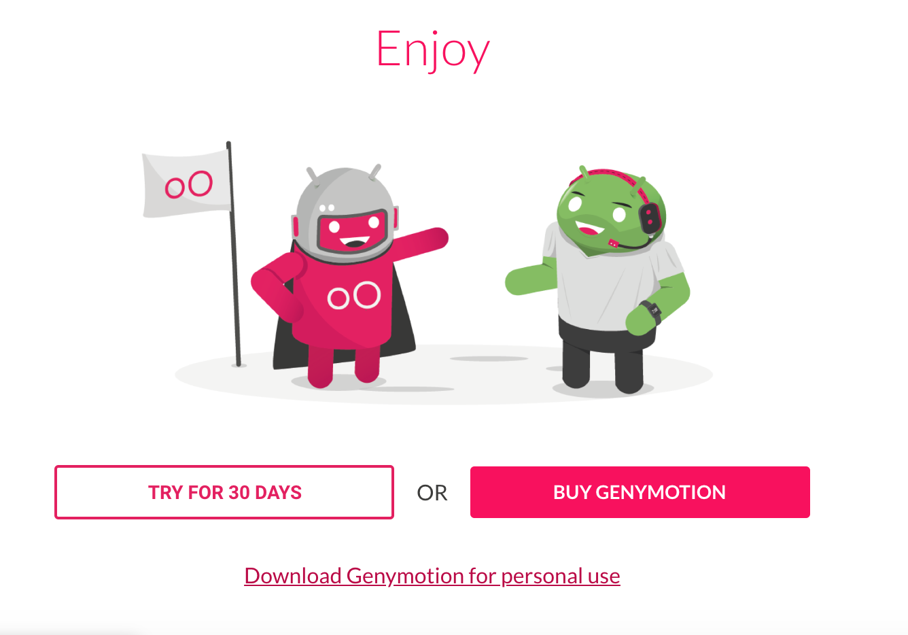4. Select “Download for personal use”  
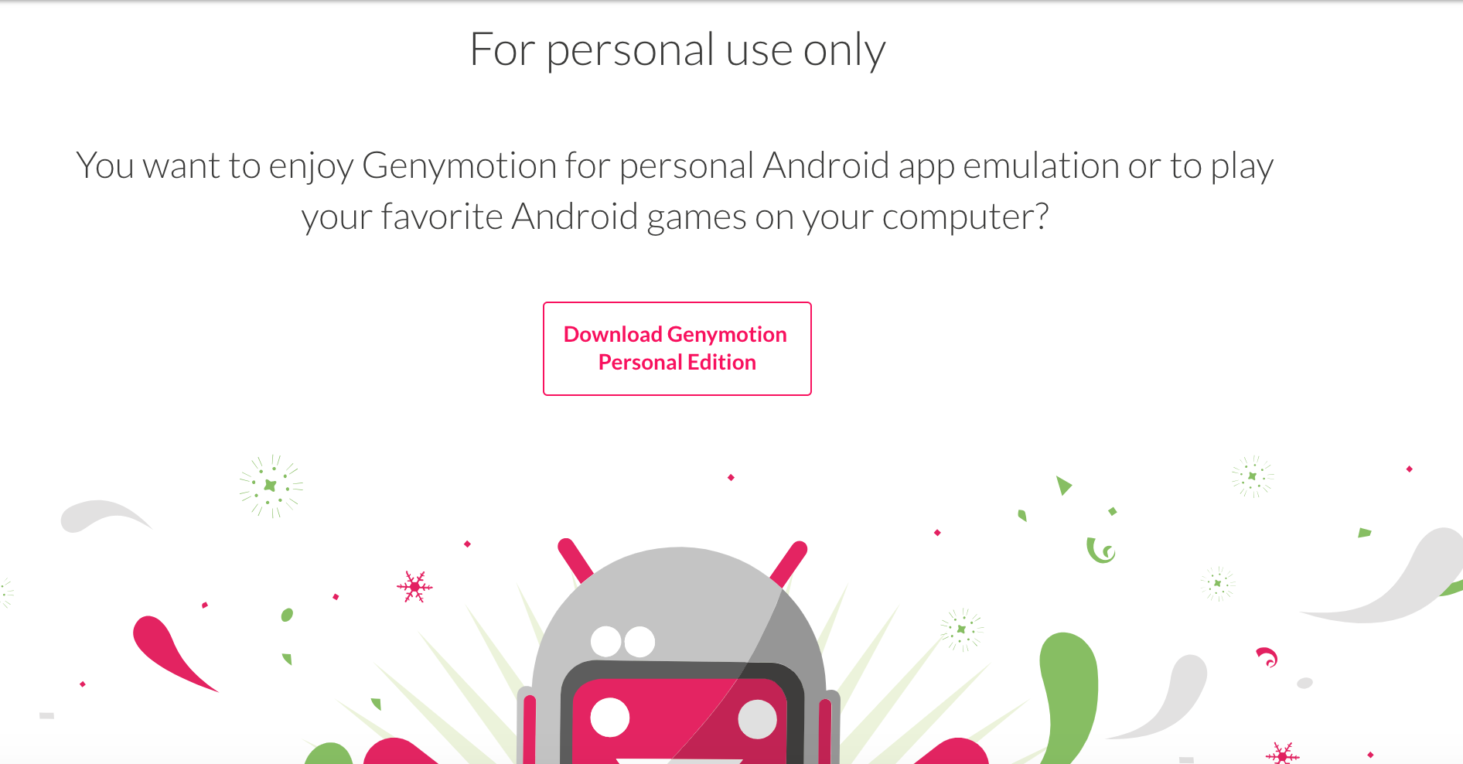  
5. Tap on “Download Genymotion personal edition”

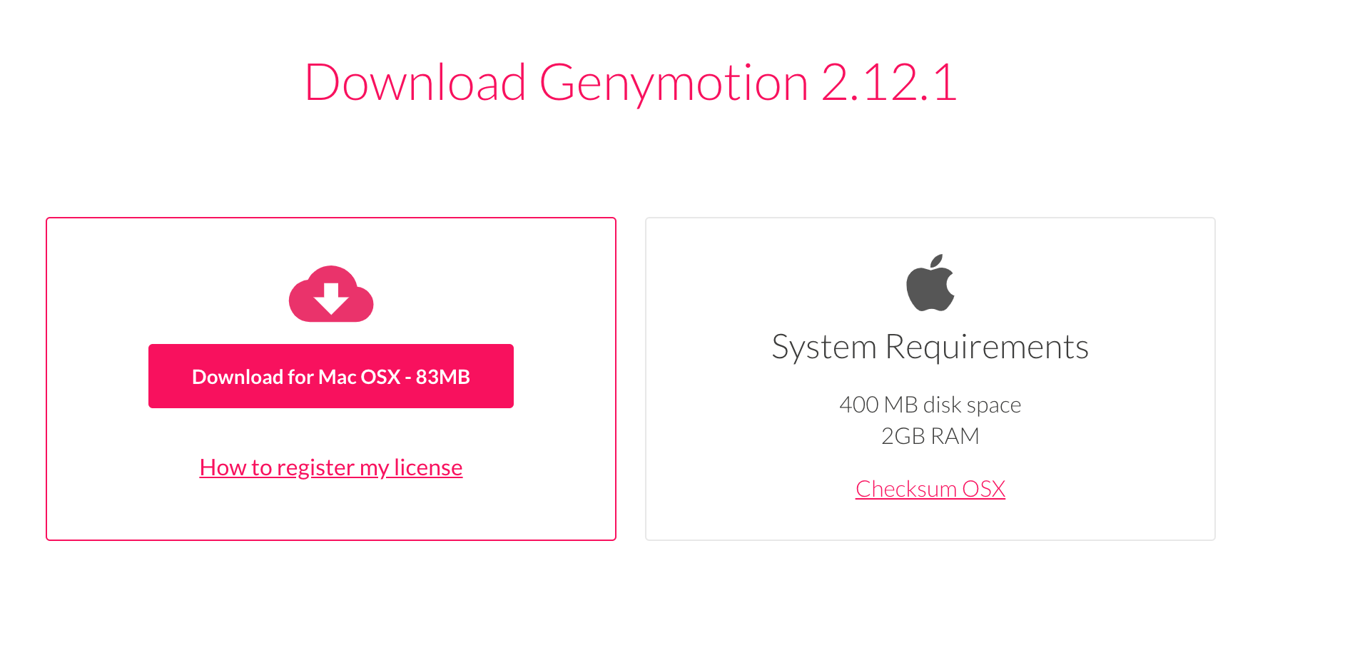

6. If you have Windows, please select “Download with **Virtualbox**”  
Installation instruction can be found by the next link:  
<https://docs.genymotion.com/latest/Content/01_Get_Started/Installation.htm>  
  
How to create the new device on the GenyMotion?

Please follow the instructions in the link  
<https://docs.genymotion.com/latest/Content/02_Application/Adding_a_new_virtual_device/Adding%20a%20new_virtual_device.htm>

How to move the .apk file on the emulator?

Start device and move .apk file to the device